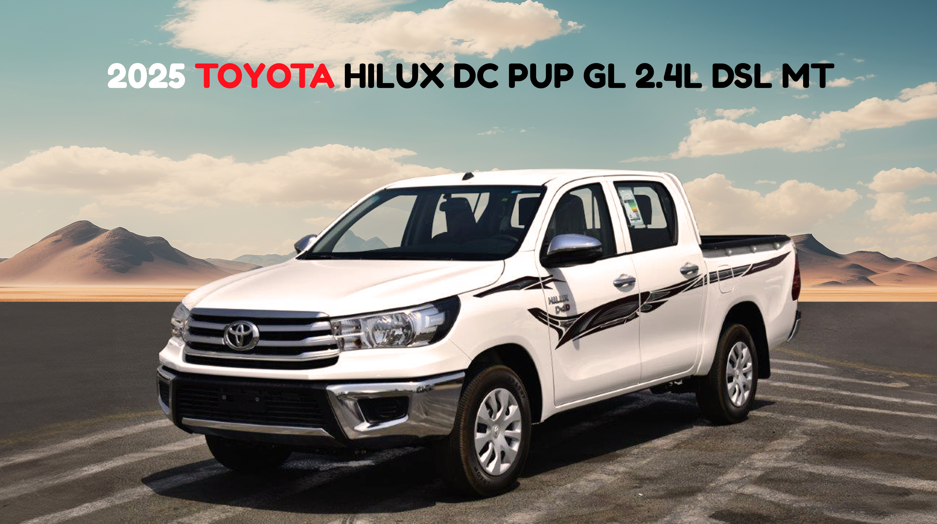

The 2025 Toyota Hilux Double Cab Pickup GL 2.4L Diesel is built for those who demand reliability, practicality, and durability in a workhorse. With its robust 2.4L turbocharged D-4D diesel engine delivering 147 HP and 343 Nm of torque, paired with a smooth 5-speed manual transmission, this Hilux is engineered for strong performance and impressive fuel efficiency at 15.9 km/L. Designed with a rugged yet refined exterior, it features 16-inch steel wheels, rear fog lamps, a durable front steel bumper, and a factory-fitted bed liner for everyday utility. The remote central locking and power-adjustable side mirrors add convenience, while its spacious double cab design offers functionality for both professional and personal use. Whether for work or weekend hauling, this pickup gets the job done.
Inside the 2025 Hilux GL Double Cab, comfort and utility are seamlessly combined. With fabric seats and a front bench that comfortably accommodates up to five passengers, it delivers a no-nonsense, practical interior ideal for daily operations or road trips. Manual air conditioning ensures cabin comfort, while features like power windows, an overhead console, and front cup holders enhance daily convenience. The sliding rear window adds ventilation options, and carpet floor mats offer a clean finish. A standout feature is the 8-inch Connected Display Audio touchscreen equipped with Apple CarPlay, DAB radio, and a USB-A port, making it easy to stay connected and entertained on the go. With intuitive steering wheel controls and functional cabin design, the Hilux proves you don't have to compromise on modern amenities in a utility-focused pickup.
Toyota prioritizes safety in the 2025 Hilux GL, equipping it with essential features that inspire confidence on every journey. Dual front airbags, ABS, and Electronic Brake-force Distribution (EBD) provide foundational safety, while Vehicle Stability Control (VSC) and Hill-Start Assist Control (HAC) ensure optimal control, even on challenging inclines. The tyre pressure warning system (TPWS) keeps drivers informed and alert, while the reliable rear leaf spring suspension supports heavy-duty performance. The chrome emblems and safety regulation kit reflect thoughtful design and compliance with modern standards. Functional and secure, the Hilux also includes front disc brakes and rear drum brakes, floor mats, and a fuel-type sticker for clear diesel Euro 5 identification. Whether you're navigating job sites or daily routes, the Hilux delivers safety, strength, and smart utility in one reliable package.

SPECIFICATION
ENGINE DETAILS  ENGINE: 2.4L, 4 CYLINDERS, DIESEL D-4D, TURBO  MAX OUTPUT: 147 HP / 3400 RPM  MAX TORQUE: 343 NM / 1400-2800 RPM  5 SPEED MANUAL TRANSMISSION  REAR WHEEL DRIVE  FUEL TANK: 80 L  FUEL ECONOMY 15.9 KM/L  DIMENSIONS L - W - H (MM): 5325 - 1800 - 1700  5 PASSENGERS (INCLUDING DRIVER) | EXTERIOR FEATURES  16 INCH STEEL WHEEL  TYRE SIZE : 215/65R16C  MUD GUARD (REAR)  FRONT STEEL BUMPER  REAR FOG LAMP  REMOTE CENTRAL DOOR LOCKING  POWER SIDE VIEW MIRRORS  BED LINER | INTERIOR FEATURES  FABRIC SEATS  MANUAL AIR CONDITIONING (MADE IN THAILAND)  OVERHEAD CONSOLE  FRONT BENCH SEAT  FRONT CUP HOLDERS  PORTABLE ASH TRAY (MADE IN MALAYSIA)  STEERING WHEEL MOUNTED CONTROLS  POWER WINDOWS  SLIDING BACK WINDOW  CONNECTED DISPLAY AUDIO "C-DA" TOUCH SCREEN 8 INCH  APPLE CARPLAY SYSTEM  DIGITAL AUDIO BROADCASTING RADIO (DAB)  USB-A PORT  2 SPEAKERS | SAFETY & CONVENIENCE FEATURES  AIRBAGS (DRIVER & FRONT PASSENGER)  ANTI-LOCK BRAKE SYSTEM (ABS)  FRONT DISC BRAKES & REAR DRUM BRAKES  ELECTRONIC BRAKE-FORCE DISTRIBUTION (EBD)  VEHICLE STABILITY CONTROL (VSC)  HILL-START ASSIST CONTROL (HAC)  TIRE PRESSURE WARNING SYSTEM (TPWS)  REAR SUSPENSION: LEAF SPRING  SIDE STRIPES  FLOOR MATS - CARPET  SAFETY REGULATION KIT  MODEL CHROME EMBLEM "GL"  MODEL CHROME EMBLEM "D4D"  FUEL TYPE STICKER "DIESEL EURO 5"

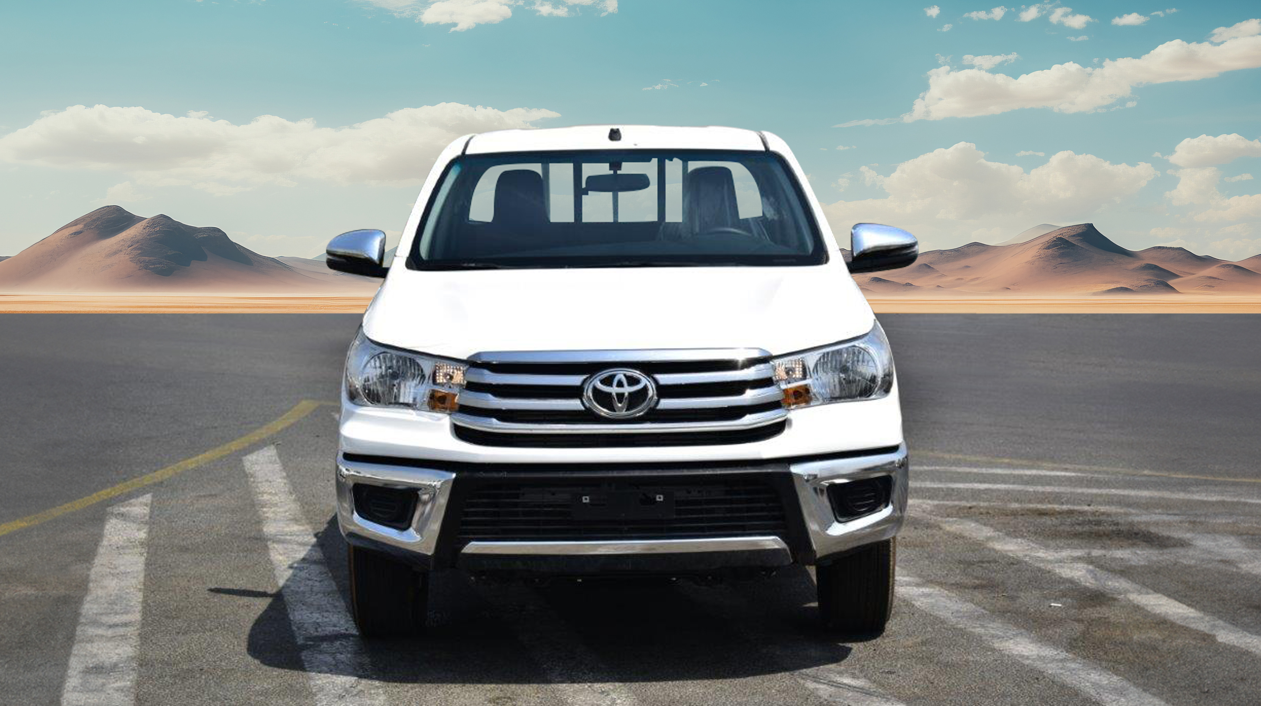
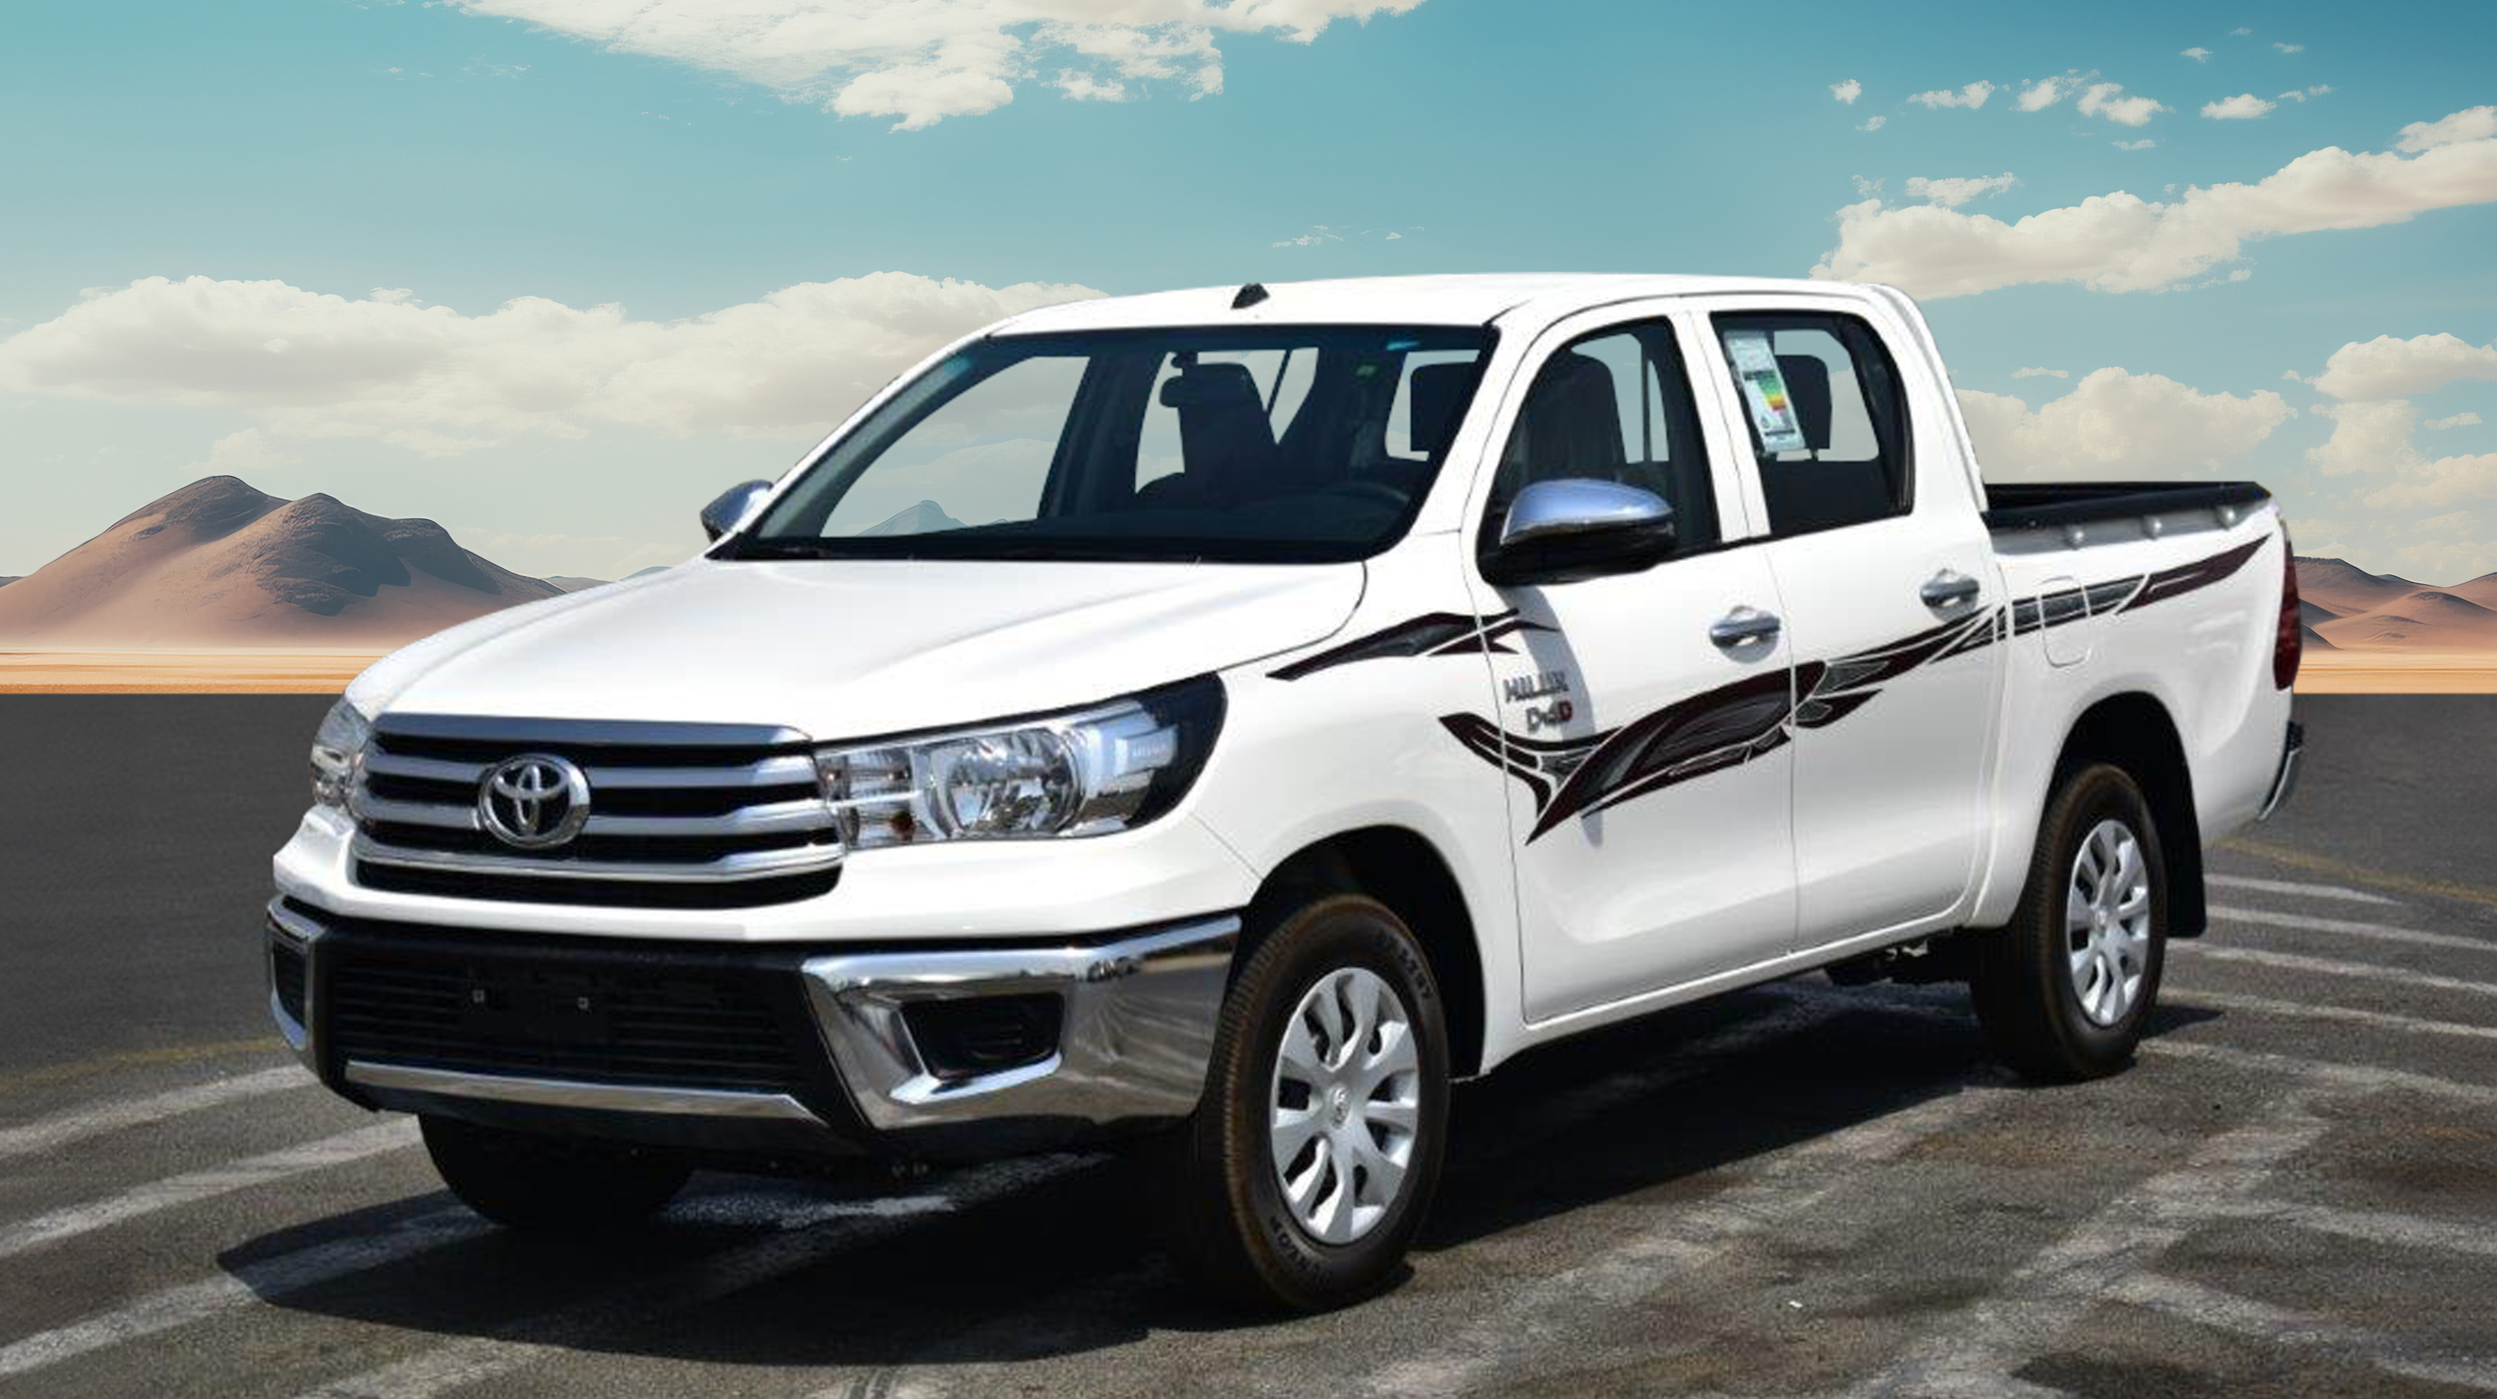
HALOGEN HEADLAMPS
FRONT STEEL BUMPER
POWER SIDE VIEW MIRRORS
TYRE SIZE: 215/65R16C
16” STEEL WHEELS
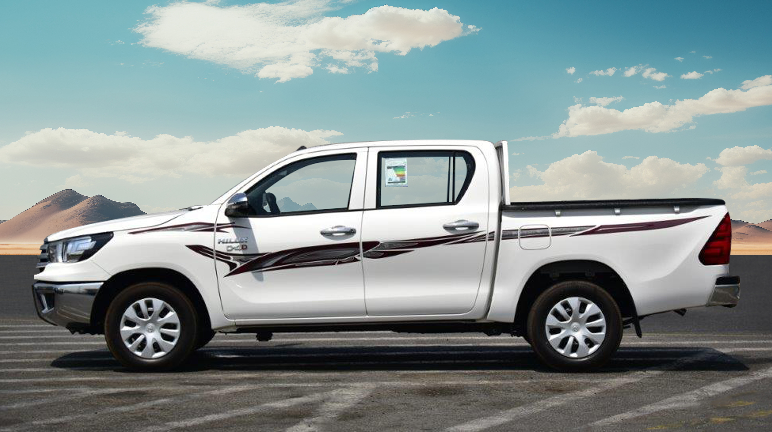
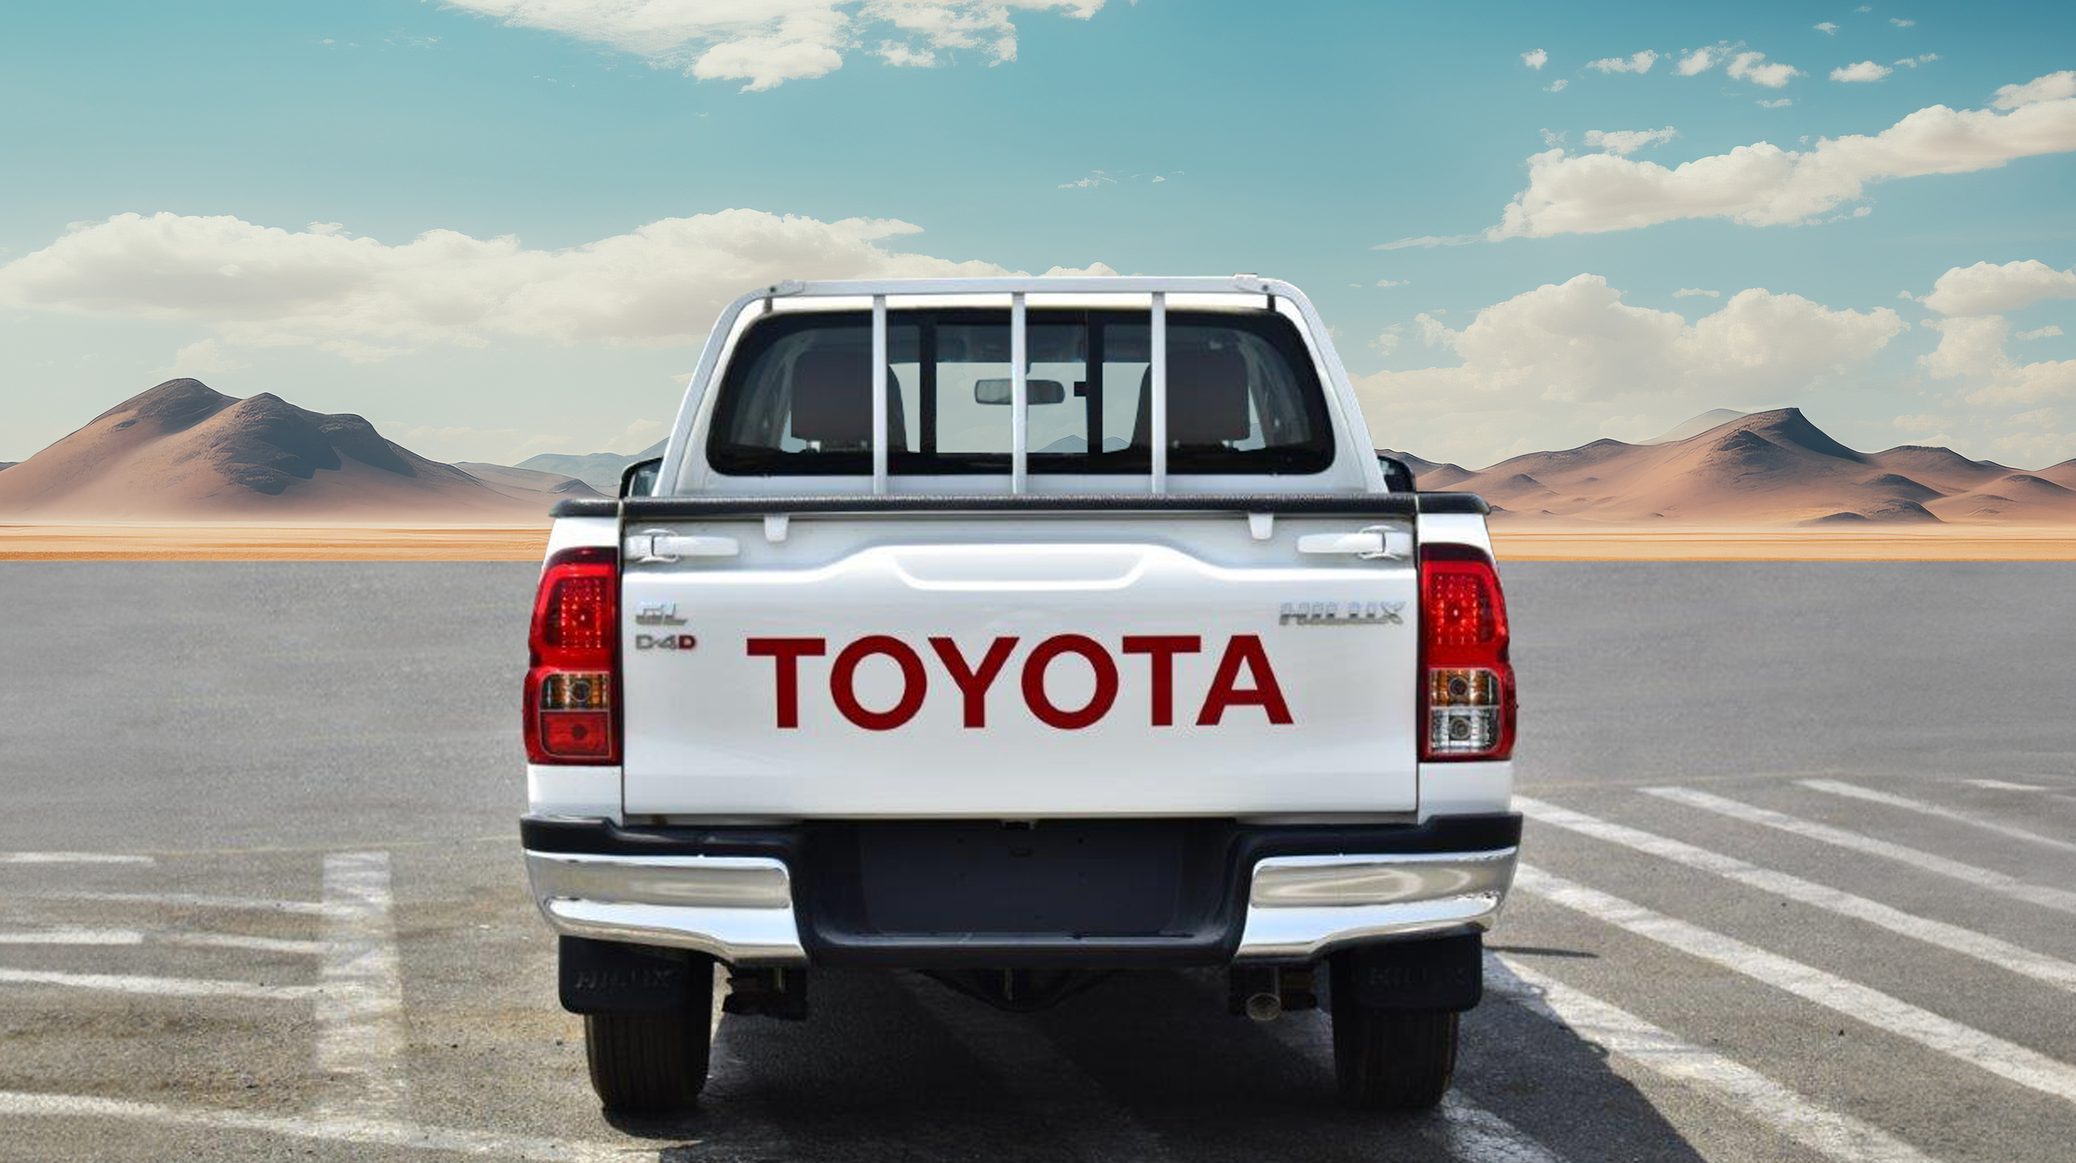
TAIL LAMP
BED LINER

MUD GUARD (REAR)
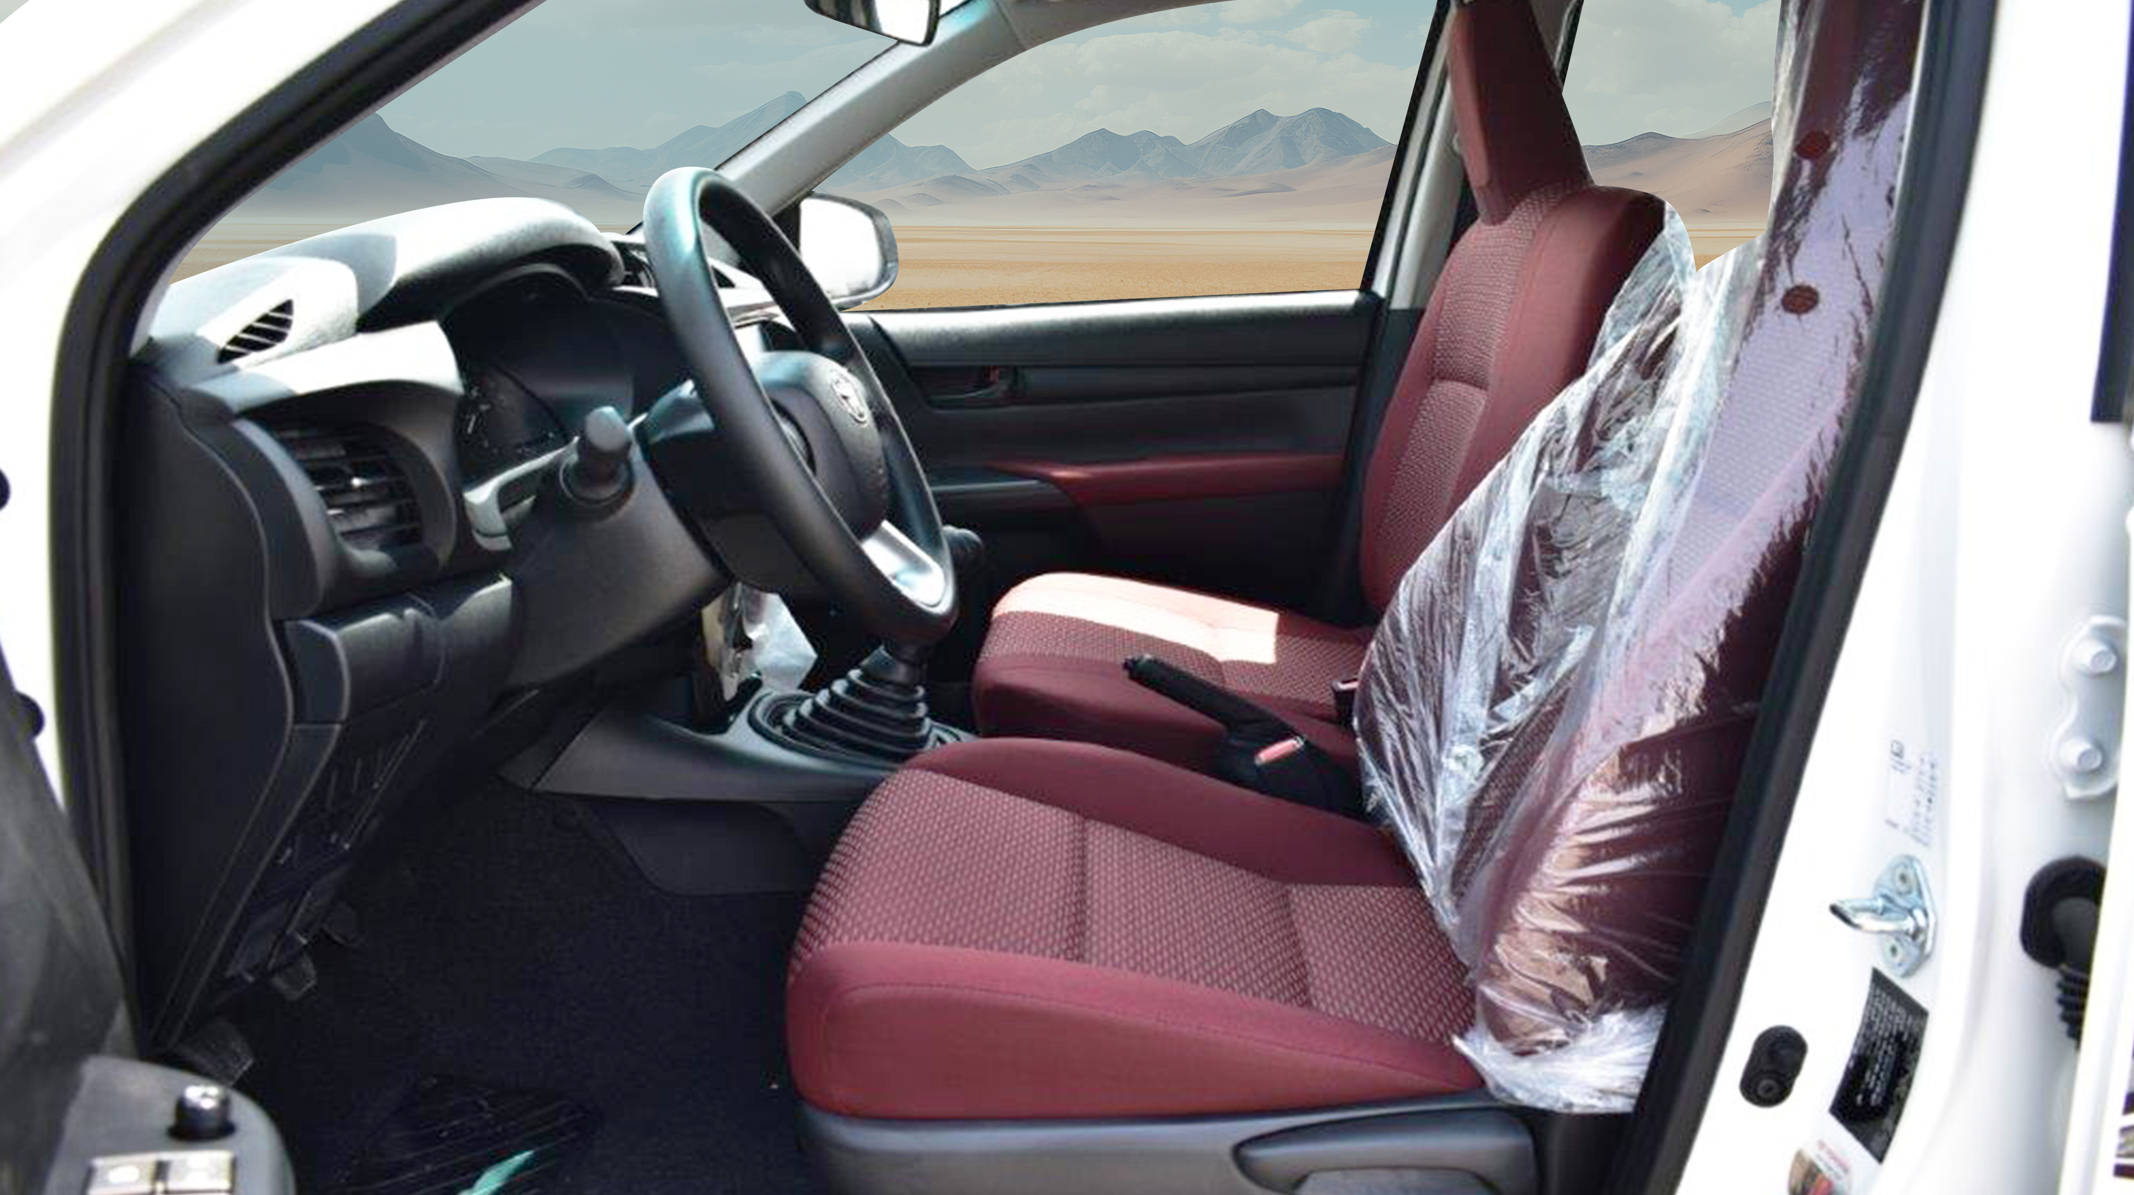
TOTAL SEATING CAPACITY - 5
FABRIC SEATS
3-POINT SEAT BELTS
REAR VIEW MIRROR
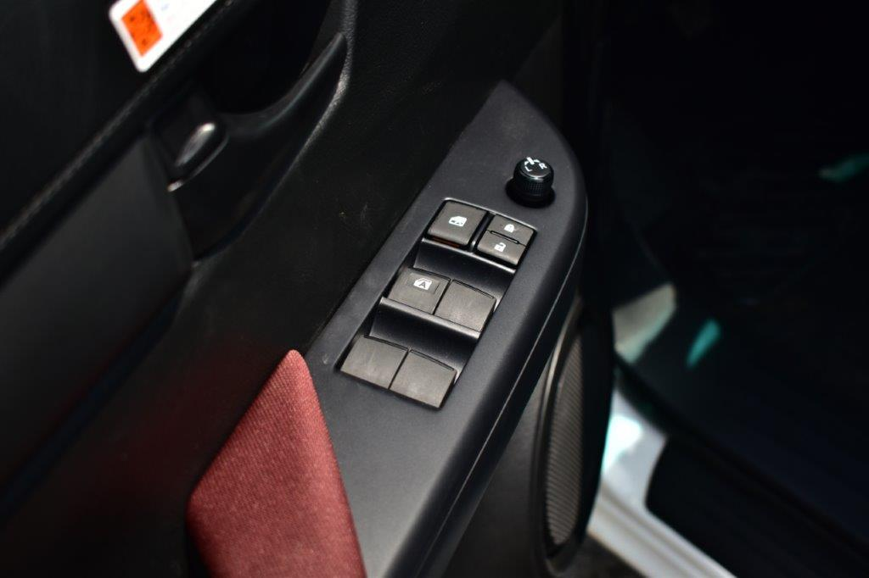
POWER WINDOWS BUTTONS
CENTRAL LOCKING
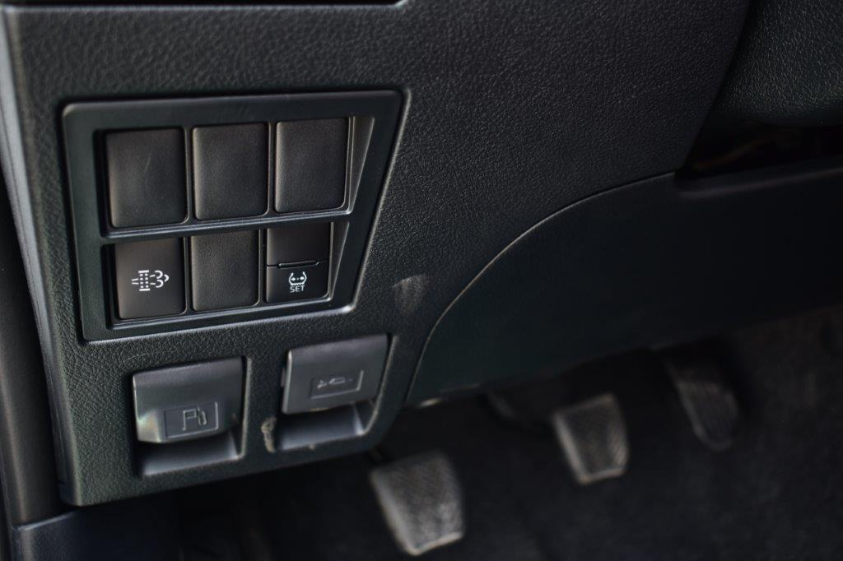
MANUAL DPF REGEN BUTTON
TPMS CALIBERATION BUTTON
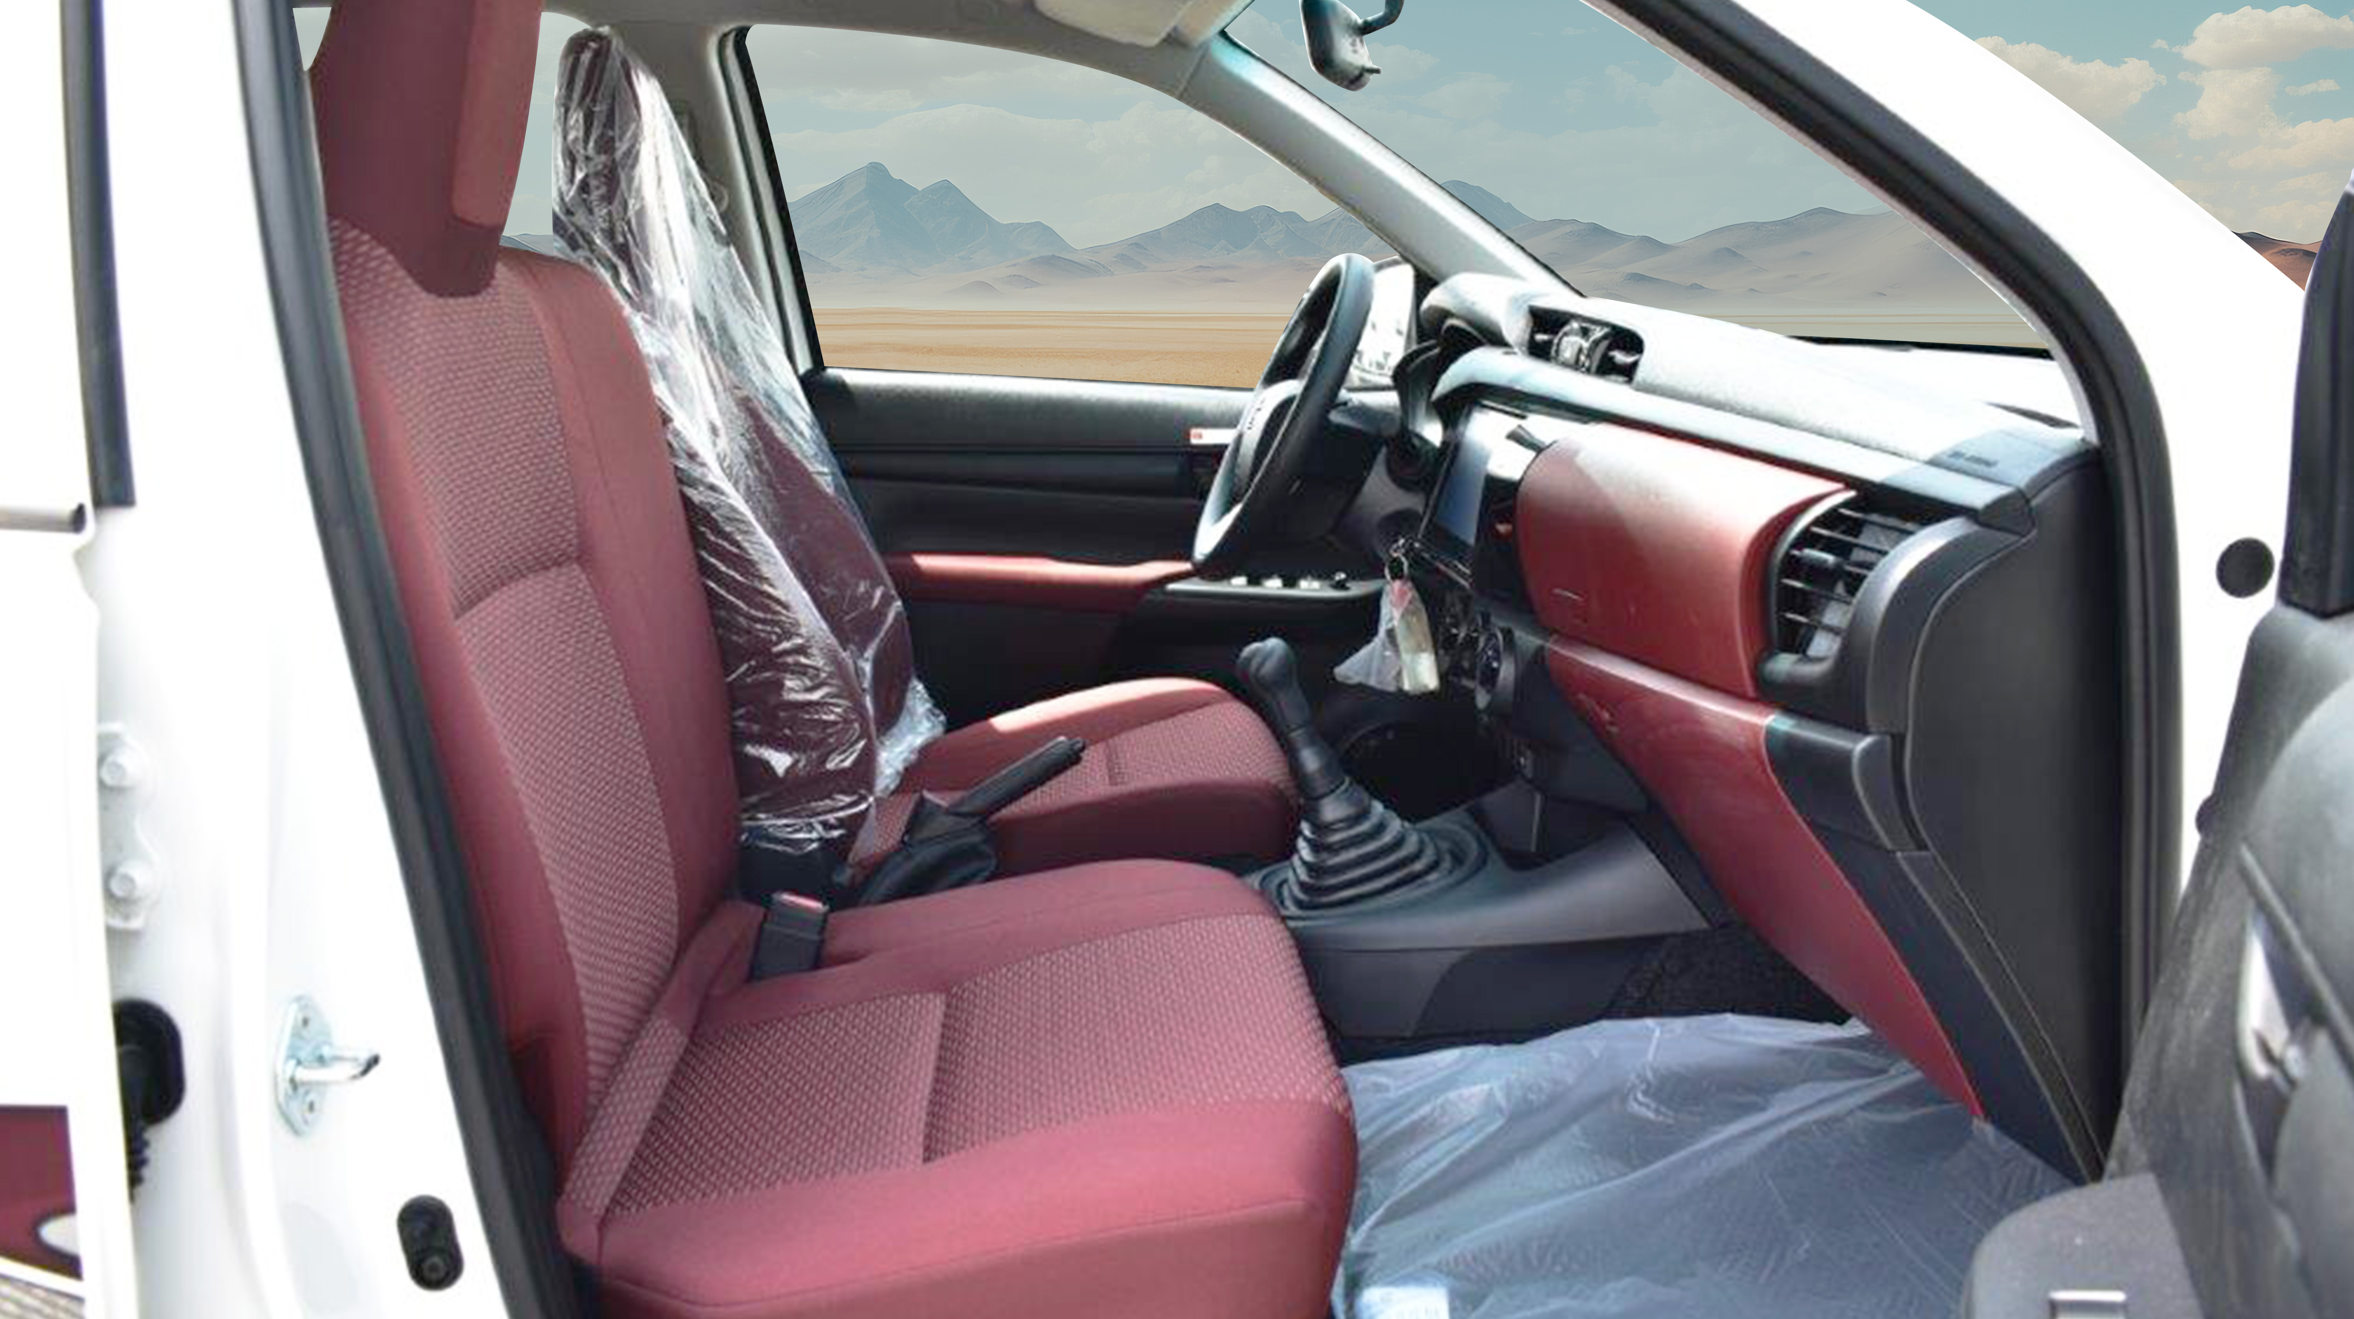
GLOVE BOX
FRONT BENCH SEAT
FABRIC SEATS
3-POINT SEAT BELTS
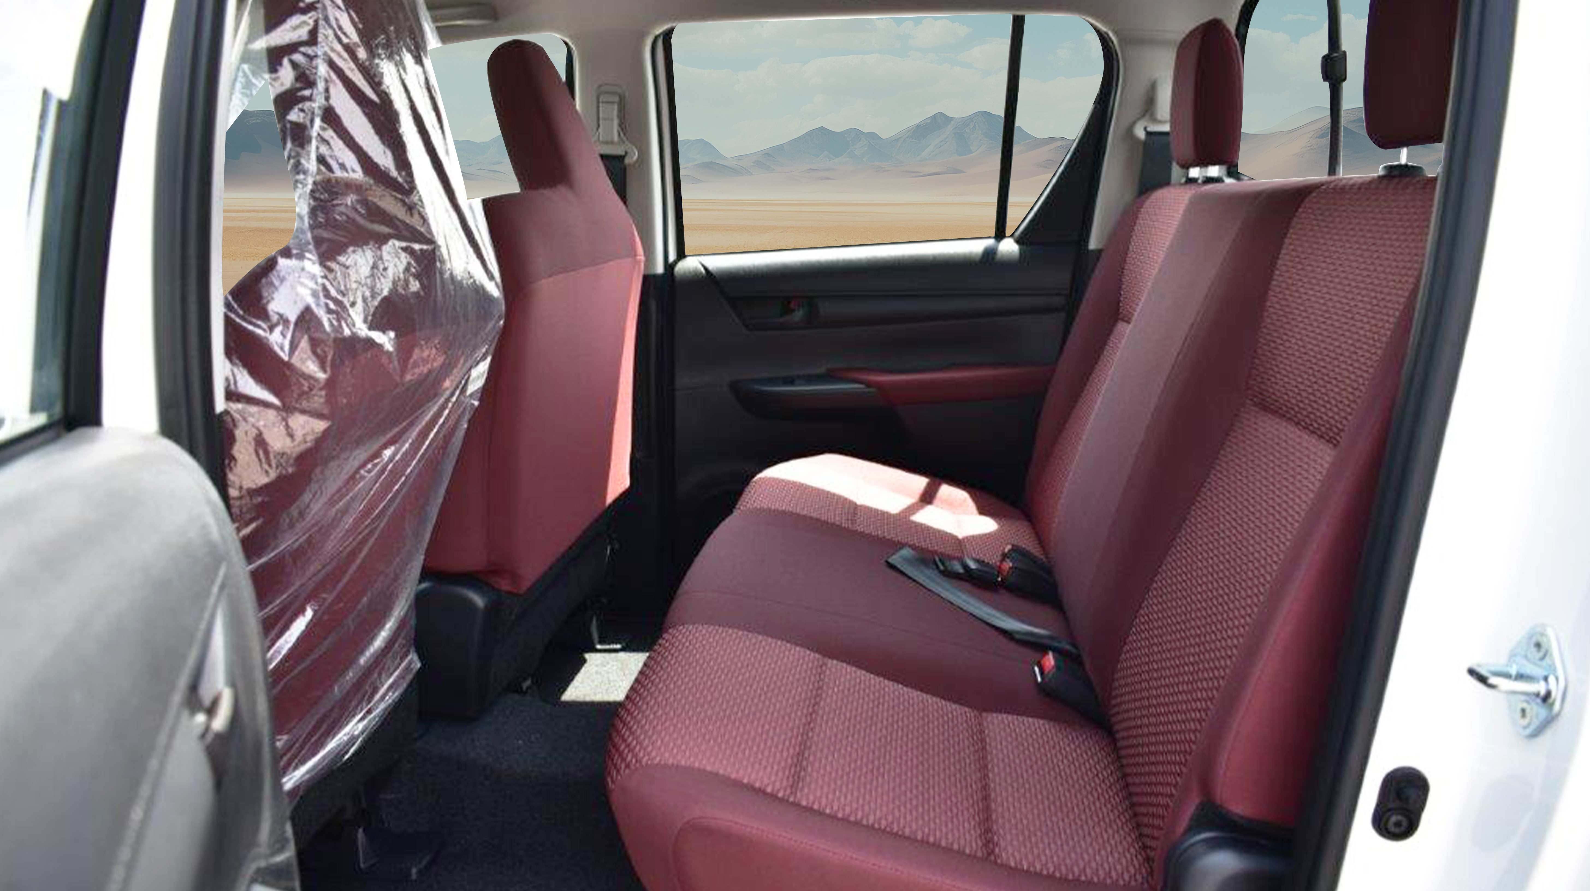
PASSENGER SEAT – FABRIC
HEADRESTS FOR REAR SEATS
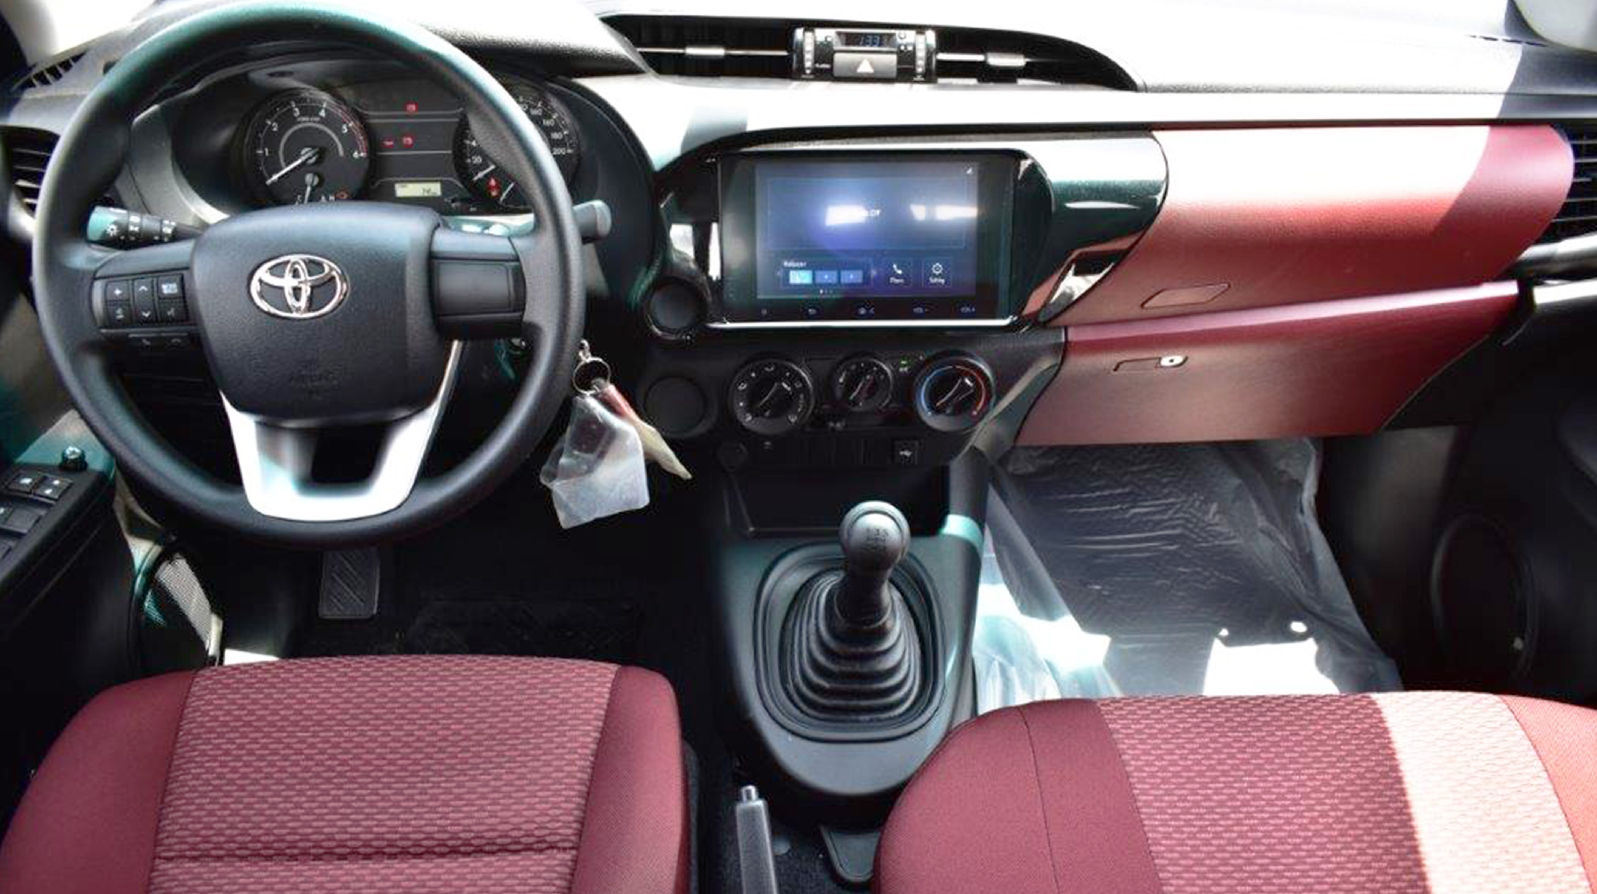
MANUAL TRANSMISSION
DRIVER AND FRONT PASSENGER AIRBAGS
8 INCH CONNECTED DISPLAY AUDIO "C-DA" TOUCH SCREEN WITH APPLE CARPLAY

STEERING WHEEL WITH CONTROLS
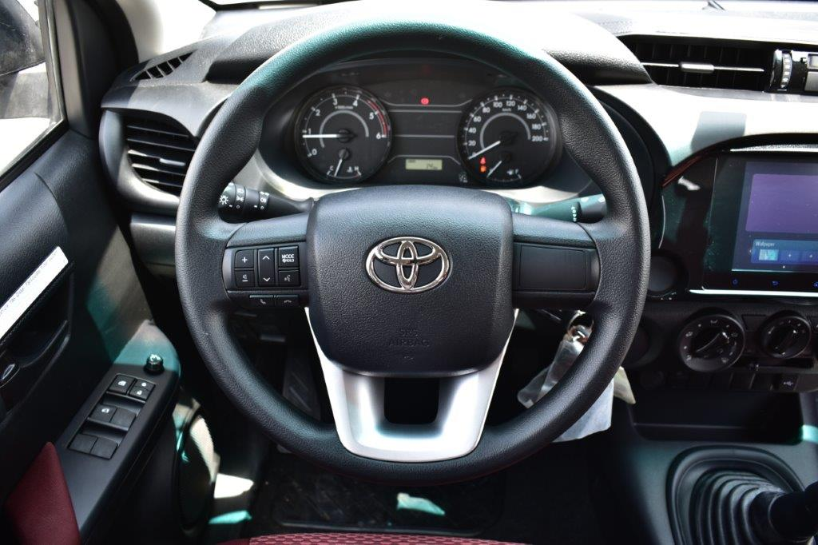

STEERING AUDIO CONTROLS

SAFETY AIRBAGS

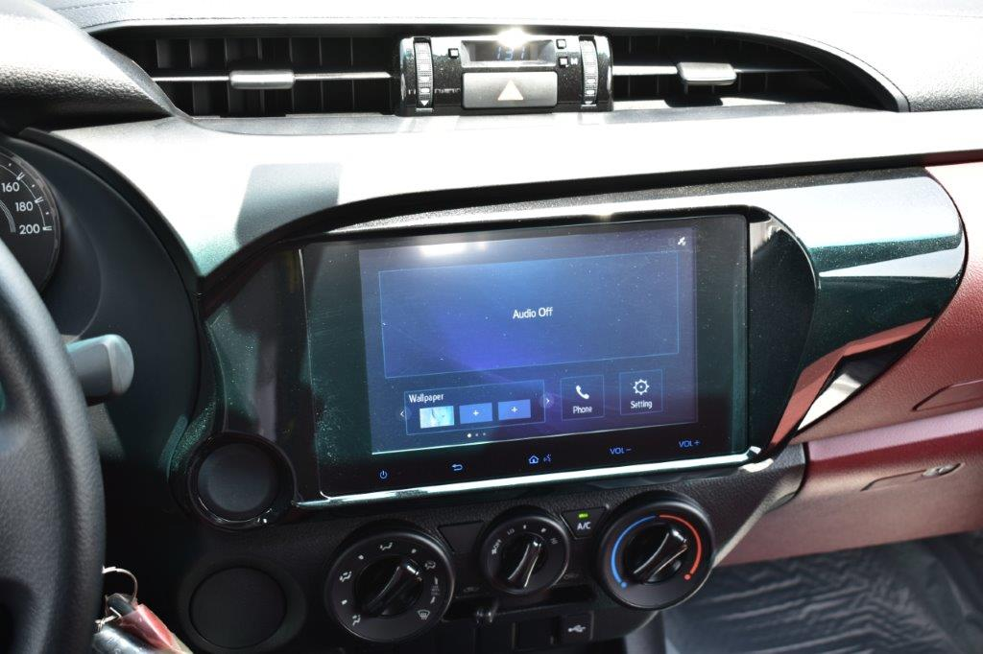
8” TOUCH DISPLAY SCREEN WITH APPLE CARPLAY
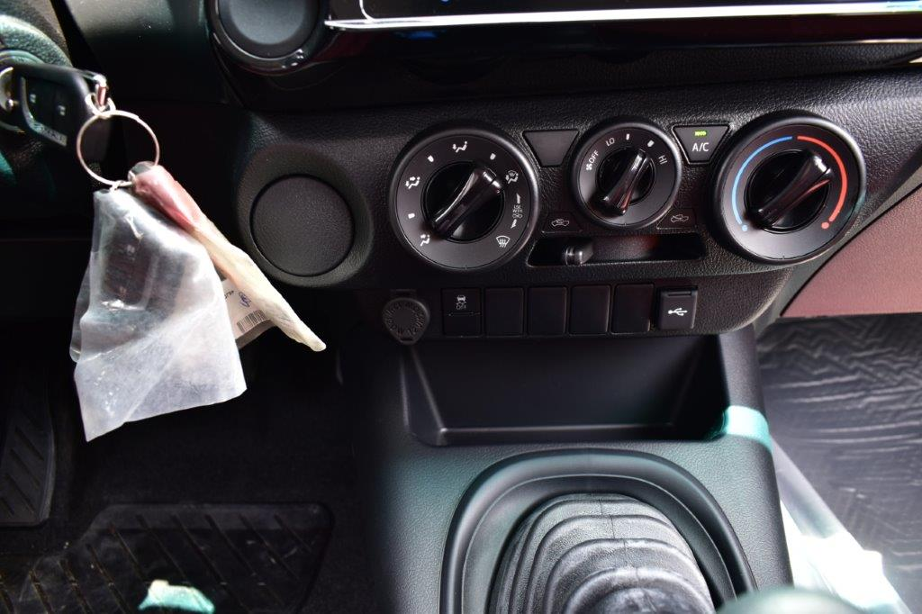
USB-A PORT
MANUAL AIR CONDITIONING
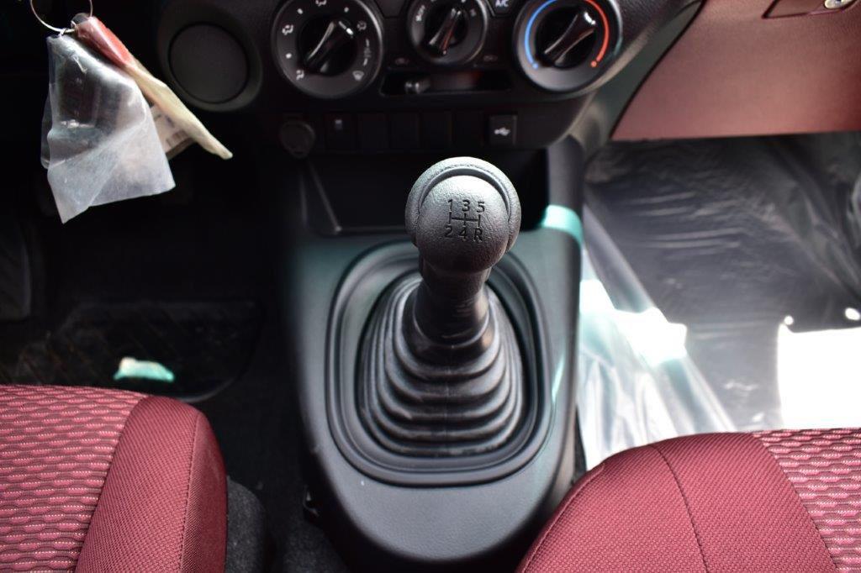
5 SPEED MANUAL TRANSMISSION
